**#Creating a customer table to perform operations**

CREATE TABLE loan_customers (

customer_id NUMBER PRIMARY KEY,

name VARCHAR2(50),

age NUMBER,

interest_rate NUMBER(5,2)

);

**#Inserting Sample values into the table**

BEGIN

INSERT INTO loan_customers VALUES (1, 'Ravi Kumar', 65, 8.5);

INSERT INTO loan_customers VALUES (2, 'Anita Sharma', 59, 9.0);

INSERT INTO loan_customers VALUES (3, 'Sundar Raj', 70, 10.0);

INSERT INTO loan_customers VALUES (4, 'Neha Verma', 45, 7.5);

INSERT INTO loan_customers VALUES (5, 'Mohan Das', 61, 8.0);

INSERT INTO loan_customers VALUES (6, 'Lakshmi Narayan', 72, 9.5);

INSERT INTO loan_customers VALUES (7, 'Kiran Bala', 34, 8.2);

INSERT INTO loan_customers VALUES (8, 'Ganesh Iyer', 60, 7.9);

INSERT INTO loan_customers VALUES (9, 'Sarita Menon', 63, 9.0);

INSERT INTO loan_customers VALUES (10, 'Rajesh Khanna', 58, 8.0);

INSERT INTO loan_customers VALUES (11, 'Asha Rani', 67, 9.8);

INSERT INTO loan_customers VALUES (12, 'Devendra Nath', 43, 7.5);

INSERT INTO loan_customers VALUES (13, 'Sneha Patil', 61, 10.0);

INSERT INTO loan_customers VALUES (14, 'Naveen Kumar', 50, 8.1);

INSERT INTO loan_customers VALUES (15, 'Shanti Devi', 74, 10.5);

COMMIT;

END;

**#Table view**

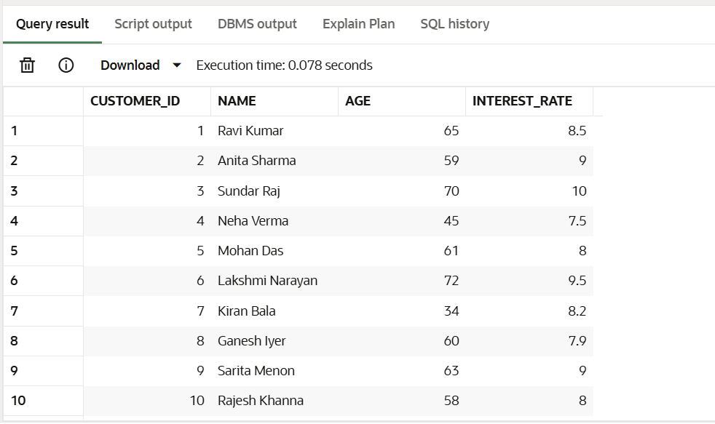

**#PL/SQL Block to Apply 1% Discount**

BEGIN

FOR cust IN (SELECT * FROM loan_customers) LOOP

IF cust.age > 60 THEN

UPDATE loan_customers

SET interest_rate = interest_rate - 1

WHERE customer_id = cust.customer_id;

END IF;

END LOOP;

COMMIT;

END;

**#OUTPUT**

**//AFTER REDUCING THE INTEREST AMOUNT TO PEOPLE BELOW 60**

